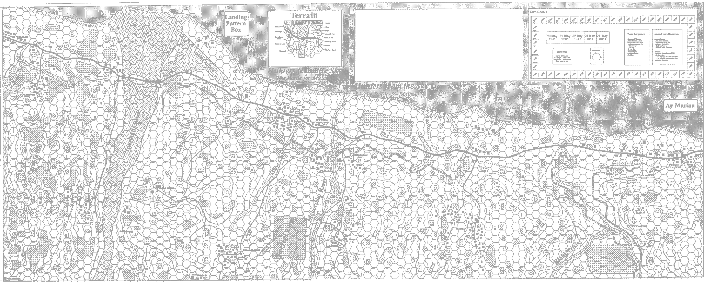

OP SHEET

Hunters from the Sky

Time:

Type:

Size:

Task Organization:
Failure Instructions:
Written Notes:

