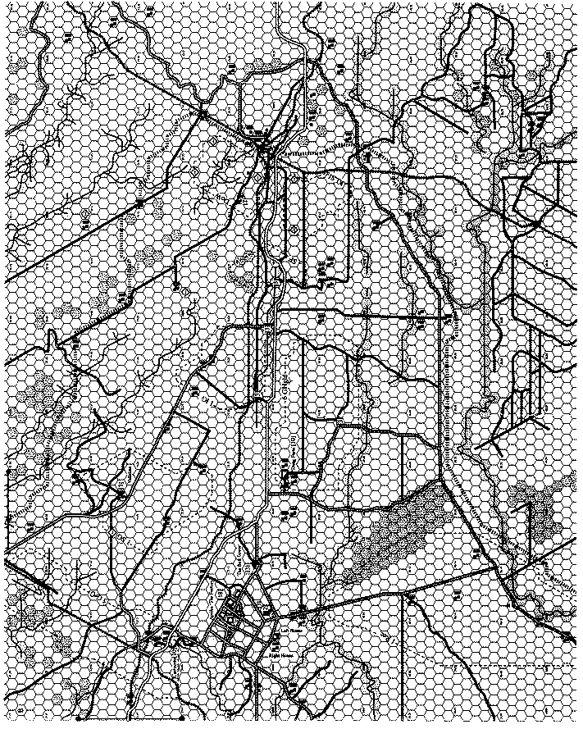

OP SHEET

Raging Storm

Time:

Type:

Size:

Task Organization:
Failure Instructions:
Written Notes:

